Serious Reportable Events:
Calendar Year 2011 & Projected 2012 Results

Bureau of Health Care Safety and Quality
June 2013

- Background and Context
  - Serious Reportable Events
  - Paper to Electronic Reporting Transition

- SRE Data
  - Calendar Year 2011
  - Projected Calendar Year 2012

- Next Steps
  - New SRE definitions and guidance from the National Quality Forum
  - Making SRE Reporting More Meaningful

Background

- SREs are defined by the National Quality Forum
  - DPH has adopted all of the events recommended by NQF

- 6 categories of events:
  - Surgical Events
  - Product or Device Events
  - Patient Protection Events
  - Care Management Events
  - Environmental Events
  - Potential Criminal Events

- Mandatory reporting required by M.G.L. c. 111 §51H
- DPH began collecting SRE reports in 2008
  - CY 2008 – CY 2010 data has been available on DPH website
  - CY 2011 and January – June 2012 data now available on website

- SRE Reporting Process:
  - SRE or potential SRE reported to DPH within 7 days of discovery
  - Follow-up report for all SREs within 30 days of initial report
  - RCA and preventability analysis required for all SREs

- In 2009, DPH promulgated regulations prohibiting facilities from charging for services provided as the result of an SRE

- All data presented here are using DPH definitions in place before October 2012
Surgical | Product or Device | Patient Protection
-Wrong Body Part  -Wrong Patient  -Wrong Procedure  -Retained Foreign Object  -Post-op death of an ASA Class I Patient | -Contaminated drugs/devices/biologics*  -Device misuse/malfunction*  -Air embolism* | -Infant discharged to wrong person  -Patient elopement*  -Patient suicide/attempted suicide*
Care Management | Environmental | Potential Criminal
-Medication Errors*  -Blood Products*  -Maternal death/disability in a low-risk pregnancy*  -Hypoglycemia*  -Hyperbilirubinemia*  -Stage 3 or 4 Pressure Ulcer  -Spinal manipulation*  -Artificial insemination error | -Electric Shock*  -Oxygen/gas lines*  -Burn*  -Fall*  -Physical Restraints*  (*) Denotes patient death or serious disability required | -Impersonation of a healthcare worker  -Abduction of a patient  -Sexual assault on a patient  -Physical assault of a patient or staff member*
- In 2012, DPH began to transition SRE reporting from paper to electronic
  - Health Care Facilities Reporting System (HCFRS)
  - Housed in Virtual Gateway

- Transition prompted examination of current system & opportunities for improvement

Results

- Each hospital reviewed its SRE data at the end of the reporting year

- Projected Calendar Year 2012 (P 2012) data are January – June 2012 rates doubled
  - Review of previous years indicates that events occur relatively evenly across the year

- DPH does not expect the projected 2012 rates to match actual 2012 results
  - October 2012 changes to SRE definitions will likely lead to an uptick in events reported in Q4

- Caution regarding data interpretation: higher SRE counts do not necessarily reflect less safe care:

    - Could reflect highly developed reporting systems

    - Could reflect culture of safety that promotes reporting

    - Hospital interpretation of what qualifies as an SRE likely varies slightly between institutions

    - Hospitals with more patient days are expected to have higher SREs

- For these reasons, DPH warns against trying to identify outliers or assess overall safety of care based on SRE data

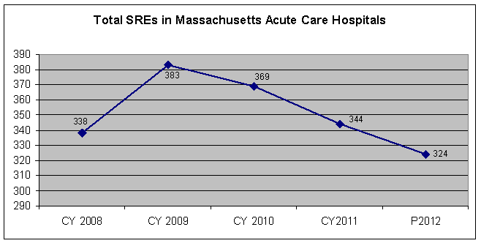

Total Events
Event Type  (Table only includes events that were reported at least once) | CY 2011 |  | P 2012
 | N | % | N | %
5.D. Fall | 188 | 54.7% | 152 | 46.9%
4.F. Stage 3 or 4 Pressure Ulcer | 70 | 20.3% | 38 | 11.7%
1.D. Retained Foreign Object | 33 | 9.6% | 52 | 16.0%
1.A. Surgery Wrong Body Part | 19 | 5.5% | 32 | 9.8%
6.C. Sexual Assault | 6 | 1.7% | 2 | <1%
6.D. Physical Assault | 6 | 1.7% | 0 | 0%
5.C. Burn | 4 | 1.2% | 0 | 0%
1.B. Wrong Patient Surgery | 3 | <1% | 4 | 1.2%
4.A. Medication Error | 3 | <1% | 16 | 4.9%
1.C. Wrong Surgical Procedure | 2 | <1% | 6 | 1.8%
2.B. Device Malfunction | 2 | <1% | 4 | 1.2%
3.B. Elopement | 2 | <1% | 0 | 0%
3.C. Suicide/Suicide Attempt | 2 | <1% | 2 | <1%
4.C. Maternal Death/Disability | 2 | <1% | 2 | <1%
2.C. Air Embolism | 1 | <1% | 4 | 1.2%
4.B. Transfusion Error | 1 | <1% | 0 | 0%
4.D. Hypoglycemia | 0 | 0% | 6 | 1.8%
5.E. Restraints/Bedrails | 0 | 0% | 2 | <1%
5.A. Electric Shock | 0 | 0% | 2 | <1%
Total | 344 | 100% | 324 | 100%
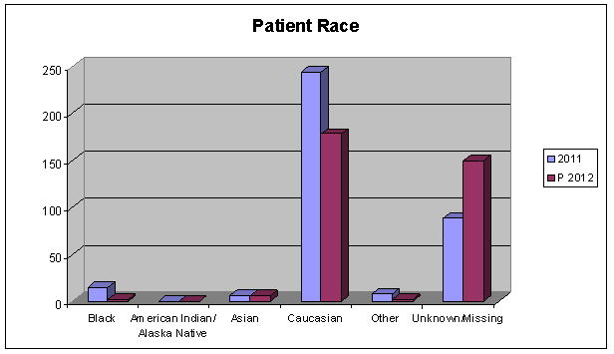

High number of “unknown” and “missing” categories make meaningful
Analysis impossible
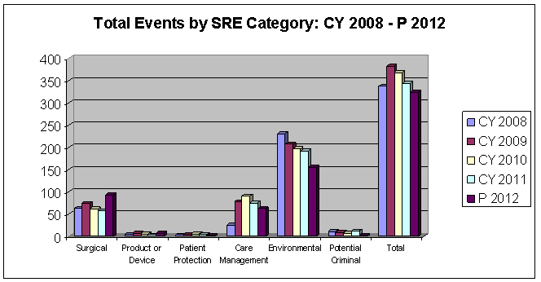

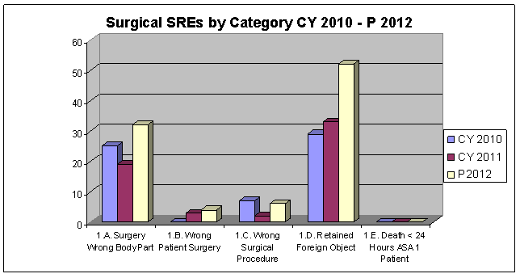

Surgical events increased from 17% to 28% of total SREs from CY 2011-P 2012

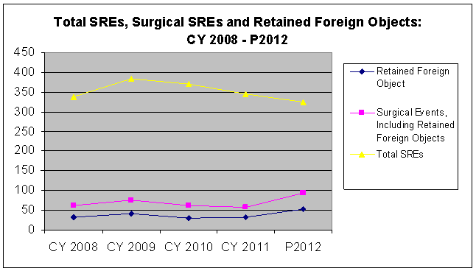

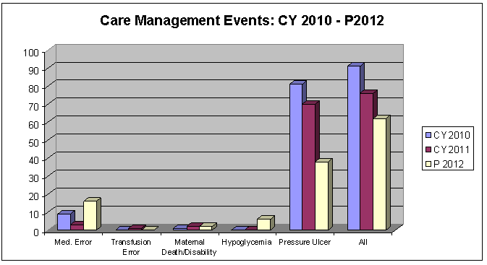

3 Care Management events were not reported between CY 2010 and P 2012

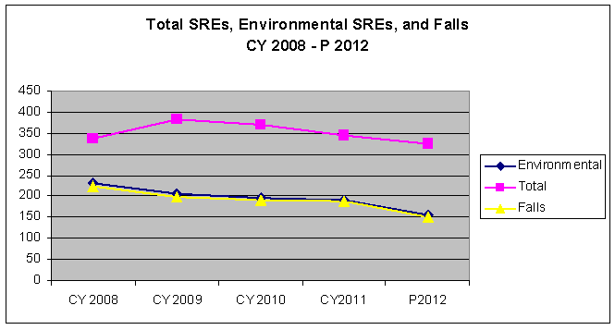

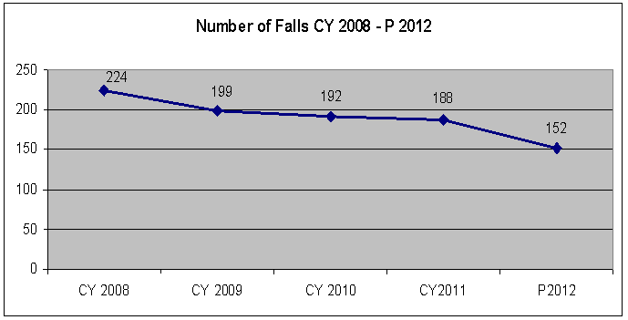

Fall Prevention Activities

- Massachusetts Falls Prevention Coalition quarterly meetings
  - 6th annual Falls Awareness Day: September 24, 2012

- Massachusetts Hospital Association’s PatientCareLink
  - Reporting of in-hospital falls
  - Fall prevention resources and education
  - Hospital success stories

- Individual hospitals aggressively tackling falls in their institutions
  - Creation of interdisciplinary Falls Teams
  - Rearranging hospital rooms to improve bathroom access
  - Minimizing fall-related injury

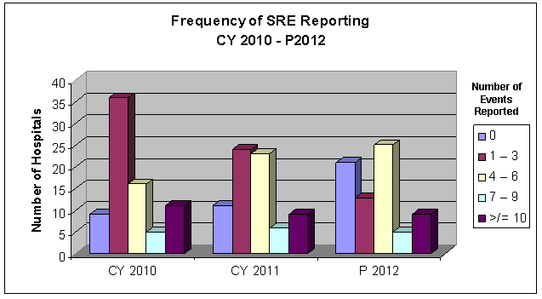

Events That Have Never Been Reported in Massachusetts | CY 2008 | CY 2009 | CY 2010 | CY 2011 | Jan - June 2012
1.E. Death < 24 Hours ASA 1 Patient | 0 | 0 | 0 | 0 | 0
3.A. Infant Discharged to Wrong Person | 0 | 0 | 0 | 0 | 0
4.G. Spinal Manipulation | 0 | 0 | 0 | 0 | 0
4.H. Artificial Insemination Error | 0 | 0 | 0 | 0 | 0
5.B. Oxygen or Gas Error | 0 | 0 | 0 | 0 | 0
6.A. Impersonation of Health Professional | 0 | 0 | 0 | 0 | 0
6.B. Abduction | 0 | 0 | 0 | 0 | 0

Looking Ahead


25
Background
NQF releases
second update
2002
NQF releases original SRE list
NQF issues first update
Mass implements mandatory reporting
2011
2008
2006
2012
Mass implements updates for first time

-Mediator
-Data specialists
-Policy analysts
-JD
-RNs
-MDs
Changes to SRE Definitions
- NQF issued an updated list of SREs in 2011

- DPH formed internal team to review NQF changes and update MA definitions

- Met with external stakeholders throughout process to share progress and solicit feedback
MHA and Mass Coalitionworkgroup

NQF Creates Definitions
DPH Interprets and Amends
Hospitals Apply Definitions
Life Cycle of an SRE Definition
Hospital submits SRE report to DPH
MHA and Mass Coalition for the Prevention of Medical Errors collaborative workgroup

28
NQF Changes
3 Care Management events have been retired:
Death/serious disability associated with hypoglycemia

Death/serious disability associated with failure to identify and treat hyperbilirubinemia in neonates

Death/serious disability due to spinal manipulative therapy

4 Events have been added:
Death or serious injury of a neonate associated with labor or delivery in a low-risk pregnancy

Patient death or serious injury resulting from the irretrievable loss of an irreplaceable biological specimen

Patient death or serious injury resulting from failure to follow up or communicate laboratory, pathology, or radiology test results

Death or serious injury of a patient or staff associated with the introduction of a metallic object into the MRI area (added into new category: Radiologic Events)

NQF: Pressure Ulcers

Patient is admitted to hospital with:
During the hospital stay Pressure Ulcer becomes:
SRE or Not?
No Pressure Ulcer
Stage 3, 4 or unstageable
SRE
Stage 1
Stage 3, 4 or unstageable
SRE
Stage 2
Stage 4 or unstageable
SRE
Stage 2
Stage 3
Not SRE
Stage 3
Stage 4 or unstageable
Reportable*
Stage 4
---
Not SRE
Unstageable
Stage 3 or 4
Reportable*
Deep Tissue Injury
Pressure Ulcer (any stage)
Not SRE

SRE Definition Changes

- “Serious disability” replaced with “Serious injury”

- Surgery expanded to include “invasive procedures”

- “Healthcare facility” changed to “healthcare setting”

- Injury to staff (in addition to patients) now included for 5 events
  - Electric Shock
  - Burn
  - Metallic object in MRI
  - Sexual Abuse
  - Physical Assault

Ongoing Improvement

- Online Reporting of Events
  - 23 acute care hospitals enrolled
  - 10 non-acute care hospitals enrolled
  - All hospitals required to be enrolled and using system by June 30, 2013

- Standardizing Root Cause Analyses and Preventability Analyses
  - Format, content, thoroughness highly variable
  - In the process of researching specific RCA tools for 3 most prevalent SRE types

- Medication error identification and prevention
  - Currently drafting regulations that will require reporting of “Serious Adverse Drug Events (SADEs)”
  - Will include questionnaire investigating context of medication error
  - Impact of nonpayment provision on healthcare costs

- DPH continues to evaluate ongoing challenges to SRE program:

  - Impacts of compelled release

  - Lack of baselines for comparison

  - Lack of feedback loop to prevent errors from occurring

  - Near misses not reported

  - Best practices insufficiently disseminated

  - Impact of nonpayment provision on healthcare costs

Special Thanks to:

Julian D’Achille, MD, MPH

Katherine Fillo, RN-BC, MPH

Caitlin Farrell, MPH

*DPH reviews on a case-by-case basis

